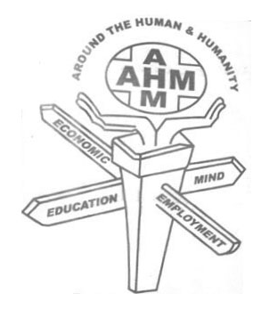
Action of Human Movement(AHM)
3/13 Madha Koil Street, Kammalam Poondi (po),
Uthiramerur(Tk),Kancheepuram(Dt) – 603 406

FIRST ANNUAL REPORT 2004 – 2005

HISTORICAL BACKROUND AND AREA OF LOCATION

Uthiramerur is being a world renowned place for inscription and electoral system (Kuda Volai Method). Which was takes place in the era of Chola King in the 7th century AD. This significant electoral system is adapting today. More than one twenty four villages make up the taluke of Uthiramerur. It contains large no of Hamlets. One among the hamlet is called Kammalam Poondi.

Our organization Action of Human Movement (AHM) has been established in Kammalampoondi. The office of the AHM is located at KammalamPoondi village; Uthiramerur town panchayath of Kancheepuram District.It is about 99km south east of the Tamil Nadu state capital Chennai and 37Kms from the district headquarters Kancheepuram. Our organization has launched its social service and has extended it to many hamlets and has been functioning very well.

Mission

“Equal and integrated community development through mind, education, employment and economics”

Vision

“Including the excluded and giving the best to the least”

SOCIO ECONOMIC CLASSIFICATION OF THE AREA

These peoples are educationally Illiterate, Socially backward and economically poor. 75% of the people are daily wage earner. They get job only in some particular seasons.

The Action of Human Movement (AHM) has registered under the society’s registration act 27 of 1975.

The board members and executive members are given below

1.G.Manivel President
2.C.Arockia Raj Secretary
3.D.Kalaivanan Treasurer
4.S.Kadirvel Executive Member
5.P.Ruthra Kumar Executive Member
6.T.dasaradan Executive Member
7.D.Prabakaran Executive Member

Main Activities of AHM

Working among rural Youth

Youth Awareness Programme
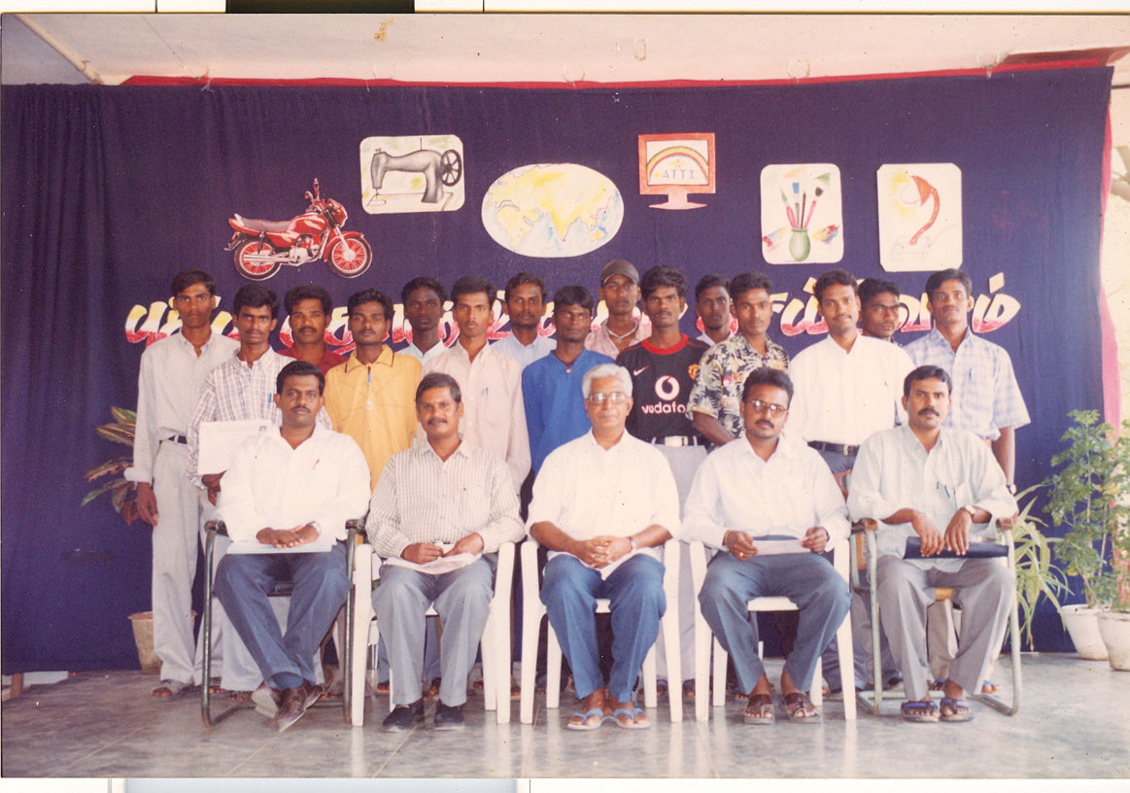

During this year(2004 – 2005) on 10.10.2004.AHM was conduct youth awareness programme for the rural youths. Because youths are the growing generation. They are the back bone of the Nation. So the AHM conduct awareness programme in personality development, Life scoping skill and carrier guidance to the youth. 14 youths those who were participated in this programme. After completion of this course the youths are ready to face their daily life problem and have a capacity to choose the right direction and also become a good Indian citizen.

WOMEN EMPOWERMENT TRAINING

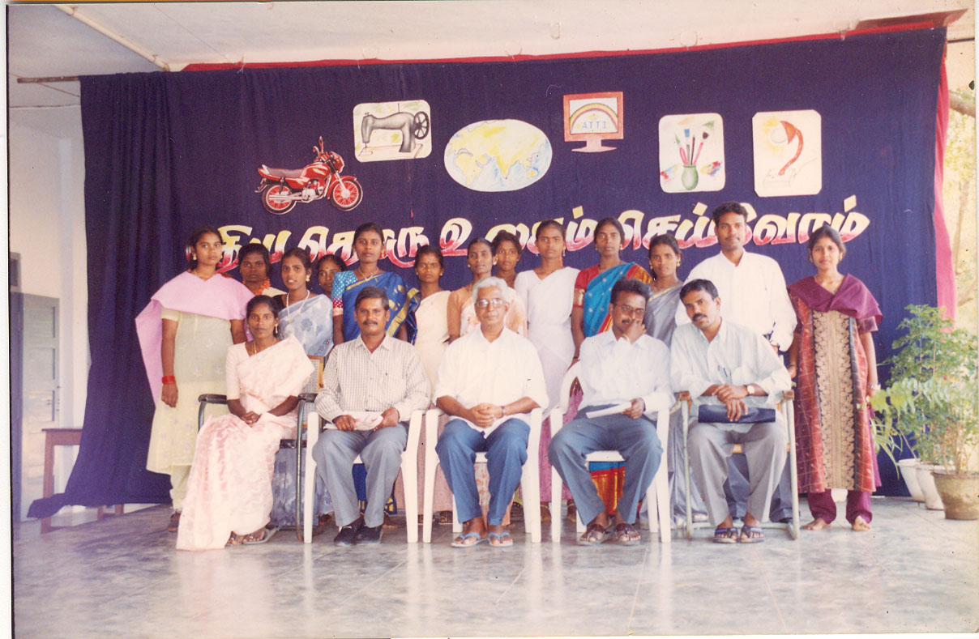

This training was conducted on 04.10.2004.There are 12 participants are join in the programme . After completion of this programme they acquire the women rights, Women education and liberation.

TECHNICAL EDUCATION FOR THE RURAL YOUTH
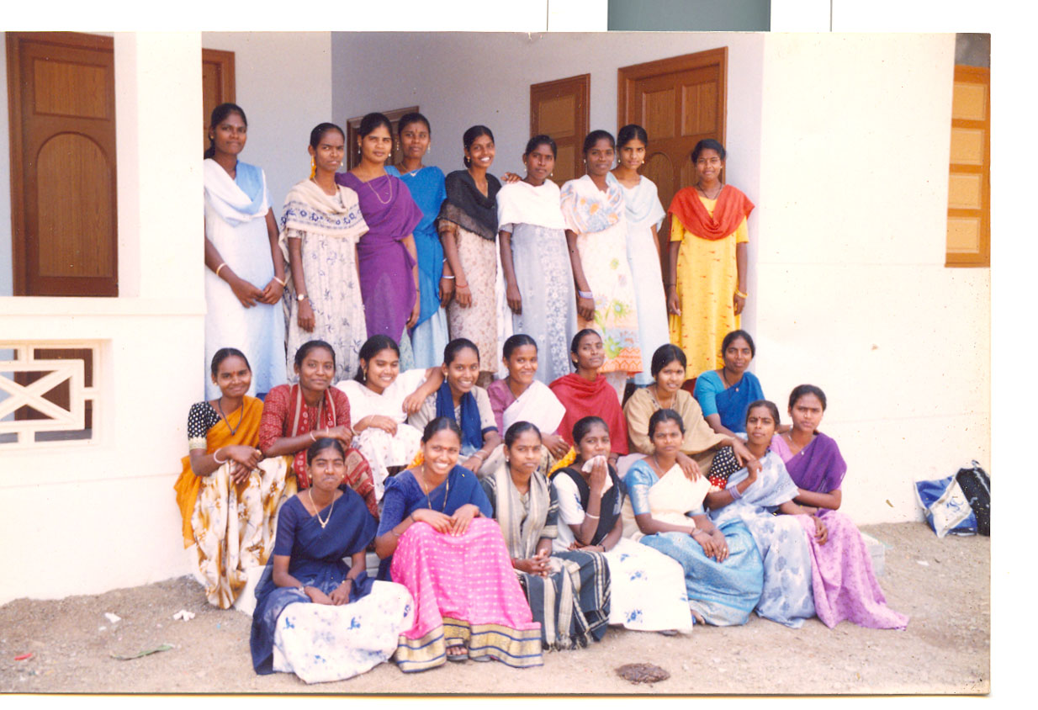

One of the best achievements of AHM is giving technical education to the rural poor youth. Right now we are collaborating with our nearest technical education community college. Every year we are recruiting 150 candidates for tailoring, computer and electrical and electronics courses. After completion of this course, they are in good position. It is very great achievement to the AHM society.

AIDS AWARENESS CAMP FOR HEALTH WORKERS
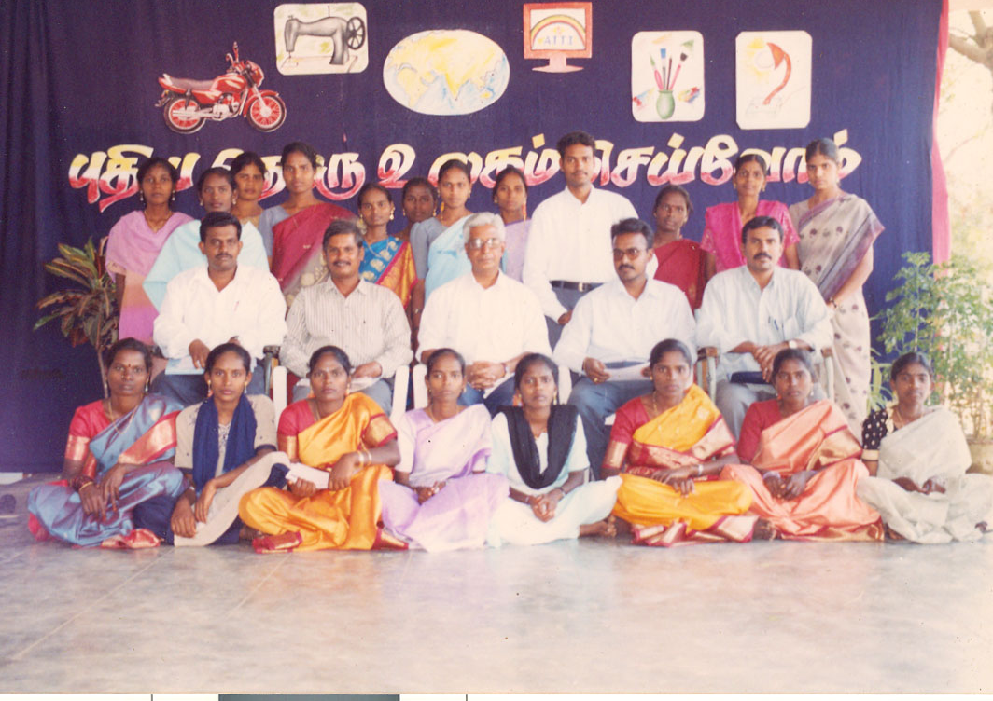

India is a growing country. Its population is growing. So AIDS awareness programme is very essential to them. So AHM conducted AIDS awareness camp to the health workers. The palm lets and booklets were distributed to the health workers. 19 health workers from various NGO’S were participated.

TSUNAMI AWARENESS CAMP

On 03.01.2005 TSUNAMI camp was conducted. The recourse person explains the symptoms of Tsunami and the precaution very well.

Financial statement of Action of Human movement (AHM)

Receipts and payments account for the period 15.09.2004 to 31.03.2005

To Donation 31660.00By Typing, Xerox postage & stationary 1939.00
To Bank Interest 5.00By Resource person fees 1200.00
By Meeting expenses 75.00
By Women and child training exp 4050.00
By Honorarium 13200.00
By Office rent 3000.00
By Village meeting exp 3000.00
By Contingent exp 485.00
By Youth training exp 3150.00
By traveling exp 51.00

By closing balance 1035.00
Bank 480.00
Cash
31665.00 31665.00

INCOME AND EXPENDITURE ACCOUNT FOR THE PERIOD 15.09.04 TO 31.03.05
To typing Xerox postage&stationeries 1939.00 By donation 31660.00
To resource person fees 1200.00 By bank interest 5.00
To meeting exp 75.00
To womens and child training exp 4050.00
To honorarium 13200.00
To office rent 3000.00
To village meeting exp 3000.00
To contingent exp 485.00
To youth training exp 3150.00
To traveling exp 51.00
To excess of income over expenditure 1515.00

31665.00 31665.00

BALANC SHEET AS ON 31.03.2005
LIABILITIES ASSETS

Capital fund o/b nill - cash in hand 480.00
Add: Excess of income 1515.00 cash at bank 1035.00

1515.00 1515.00

Abstract of programmes conducted by AHM society during the year 2004 – 2005

Name of the Camp No of beneficiaries

1. Youth awareness camp - 14nos

2. Women empowerment training - 12nos

3. Technical Education - 150nos

4. AIDS awareness camp - 19nos

5. Tsunami awareness - 24nos

6. Cultural training - 20nos

TOTAL - 239

